### **Central Repository - Learning Content**

Create and Manage the Learning Content & Curriculum in the Central Repository



Written By Scott Smith

Created one year ago

The system provides the ability to create & manage all your Learning Content or Curriculum content in a single location.

**Navigation:** Click on the Courses menu and Central sub-menu to navigate to the Central page.

**Security:** This page is visible only to the Business and Franchise/Center Admins, Executives and Coordinators and any other user roles who have been assigned permissions.

All the created learning content is displayed in the grid in a hierarchy (Courses, Levels, Challenges). You have the option to expand all or collapse all by clicking on the icons next to the “Add New” button. The following information is displayed in the grid -

Title - Name of the Curriculum item (Course, Level or Challenge)

Item Type - Course, Level or Challenge

Course Type - Type of the course to which the item belongs

Course Category - Category of the course to which the item belongs

Tags - Tags of the item

Status - Active or In-Active

Stage - Specified in which stage the item belongs

Points - Points assigned to the Challenge

Ages - Age range of the Students for the Course.

“Ordering” button provides the ability to re-order the items. Franchise account users can’t reorder the items created by the Business account users. Clicking on the button will open a popup. In the popup, the items are displayed in the corresponding item types. You have the ability to reorder the items by dragging up or down. For Level items, you will need to choose the course for which you want to reorder the Levels. For Challenge items, you will need to choose the Course & Level for which you want to re-order the Challenges.

## **Central Page - Courses**

The system provides the ability to create Courses on the Central page which are used to define the learning content, create/manage Classes and student enrichment.

Click on the “Add New” button and Course option to create a new Course.

In the popup, you have the ability to specify the following information -

**Note:** All the fields displayed here are customizable including the ability to set Permissions (like who can view or edit the content). The customizations can be done in “Admin > System Config > Form Templates > Course”

**Course Name -** Specify the name of the Course.

**Course Status -** Specify the status of the Course (Active or In-Active). By default, the Active option is selected.

**Category -** Specify the Category of the Course. In the dropdown list, you have the ability to select the Course Type & Category. Refer to the below diagram which explains the flexibility and the hierarchy to create & manage the Courses & Classes -

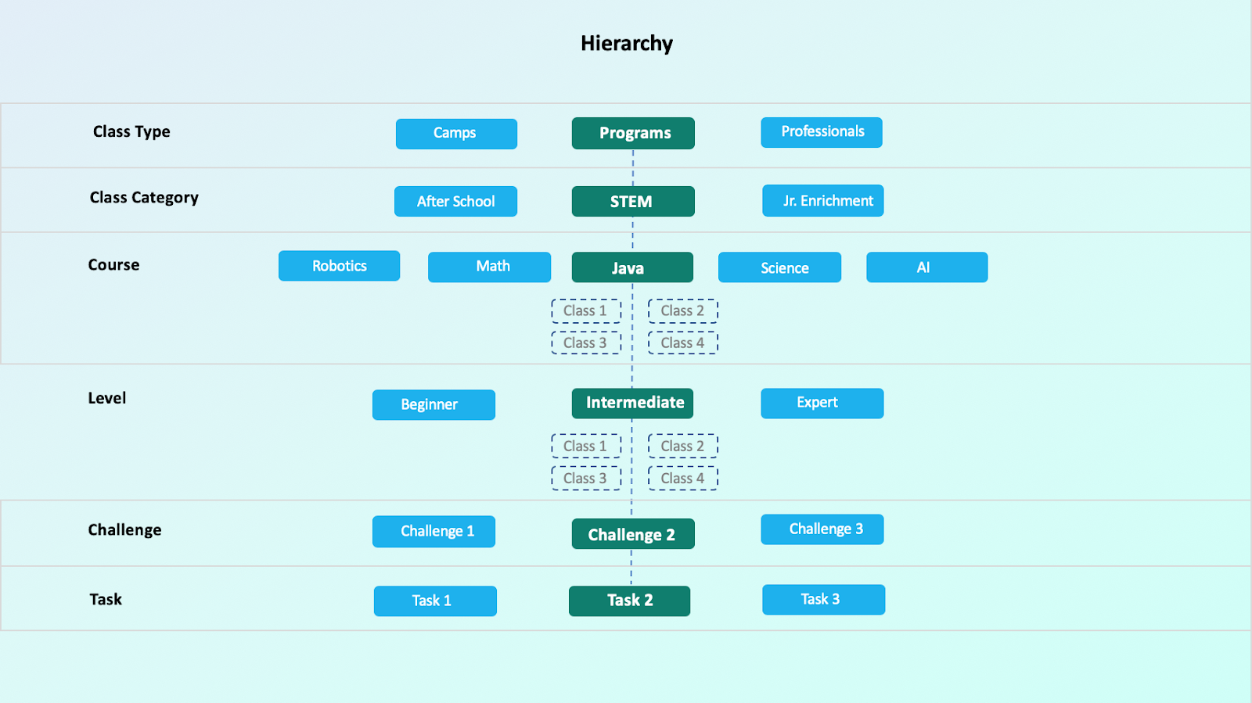

You can create the Types and Categories in “Courses > Classes > Types Setup” and “Courses > Classes > Categories Setup”.

**Instructor/Staff -** Select the Instructor/Staff that is the owner of this Course.

**Course Image -** By default, an image is selected but you have the ability to change the image by hovering on it and clicking on the upload icon.

**Tags -** Click on the settings icon to manage the Tags for the Course. These Tags are used to tag the course with a text & color to differentiate with other courses based on your preference which will help identify them quickly. In the popup, you have the ability to add/update/delete tags and set colors for each tag. In the Course popup, click on + icon for the Tag to add a Tag to the course and start typing a tag to choose from the existing list. You can enter a text and tab to automatically add the text as a Tag.

**Details >**

**Stage -** Specify the Stage field to mention in which Stage the Course is in. By default, the Active option is selected.

**Online/In-Person Training -** Specify if this Course will be conducted as an Online class or In-Person class. This is an optional field.

**Age From -** Specify the limit from which Age the Student is eligible to take the class. This is an optional field.

**Age To -** Specify the limit until which Age the Student is eligible to take the class. This is an optional field.

**Accepted Gender -** Specify which Gender can attend the Class.

**Classes -** The “Manage Classes” button will not be enabled until you create the Course. Create the Course and click on the “Manage Classes” button. In the popup, the following information is available -

1. All the list of classes for the Course are displayed. For each class, you have the ability to set the Class to Active or In-Active by changing the switch of the Active column in the grid. The major Class details are displayed in the grid columns for each class. You have the ability to edit or delete the created classes.
2. Clicking on the “Add New” button will provide the ability to add a Class to the Course.
3. **“Price Suggestions”** button is available for the Business Account Users. Clicking on the button will open a popup that provides the ability to set the Price and Price range for the Course and its levels to guide the Franchises/Centers to define their class prices.
4. **“Field display settings”** button provides the ability to set which fields can be displayed in the Class Enrollments page. To use the page or the embedded script on your website, go to “Courses > Classes > Classes Setup”. On this page, you can use the URL for each Course Type or click on “Generate Embedded Script” for each Course Type and use that script or link on your website.

The number of created & active classes are displayed as a link under the “Manage Classes” button.

**“Total Enrolled”** field displays the number of enrolled students.

**“Active Students”** field displays the number of Active students enrolled in the class.

**Overview -** Specify the high-level overview of the course in the rich text editor. This will be displayed in the Enrollments/Classes Page or embedded script that you can place on your website.

**Curriculum -** All the Levels and Challenges for the Course are displayed in the Curriculum are displayed here.

1. Clicking the “Add Level/Challenge” button provides the ability to add a new Level or Challenge for the course.
2. You also have the ability to import Challenges from an excel spreadsheet.
3. Clicking on the “Board Settings” button will open a popup to set if the Challenges for the course should be automatically be added to the Student board when the Student enrolls in the Class. If the setting is OFF then it provides the ability to manual add instead of automatically adding all.
4. In the grid, for each Level, you can import challenges, view details of the Level and add challenges for the level. For each Challenge, you can view the details of the Challenge, Points set for the Challenge, view any Test/Assessment for the Challenge.

**Instructions -** Specify any instructions on how the Course should be handled.

**Instructors Notes -** Specify any notes for the Instructors on how to conduct the Course and its classes.

**Discussion -** This tab can be used to perform any internal discussion for maturing the process or content of the course, any questions or comments about the course, etc. All the users who have access to the page and the course popup can discuss, reply to a comment, Like, edit or delete the comments.

**Attachments -** This tab can be used to attach and manage any documents for the Course. Clicking on “Add Attachments” will open a popover to add Attachment from different sources like Computer, Dropbox or Google Drive. If you select Google Drive, you will have 2 options. 1) You can add the Google Drive document link and 2) You can upload the document from Google Drive into the System. For the 1st option, any update made to the Google Drive document will reflect the changes here. If the link changes in Google Drive then you will no longer be able to access from here. For the 2nd option, any update made to the Google Drive document will not reflect the changes here because the file is uploaded to this system. Once the attachments are added, you have the ability to download, delete or view the documents. The Viewer provides the capability to view the documents without the need to download them. However, there might be some files that you can’t view.

The security of the attachments on who can add/view/download/delete can be managed in “Admin > System Config > Attachments Config”.

**Checklist -** This tab can be used to add any checklist items or tasks related to the Course. You have the ability to add/update/remove/reorder the items/tasks.

**History -** This tab provides the activity/history details of the course information.

You have the ability to copy the course by clicking on the copy icon on the Course popup top bar.

## **Central Page - Levels**

The system provides the ability to create Level on the Central page for the Courses which are used to define the learning content, create/manage Classes for the Course or Level and student enrichment.

Click on the “Add New” button and Level option to create a new Level (OR) you can create the level for a Course by clicking on the + icon in the grid for the course row and select the Level option. If you select the Level option from the grid then the Level will be created under the Course. If it is selected from the Add New button then you will need to choose the Course in the Level popup.

In the popup, you have the ability to specify the following information -

**Note:** All the fields displayed here are customizable including the ability to set Permissions (like who can view or edit the content). The customizations can be done in “Admin > System Config > Form Templates > Level”

**Title -** Specify the name of the Level.

**Parent -** If the Course for the Level is already selected then it will display the course name here. If it is not selected then you have the option to choose the Course to which the Level belongs.

**Tags -** Click on the settings icon to manage the Tags for the Level. These Tags are used to tag the course with a text & color to differentiate with other Levels based on your preference which will help identify them quickly. In the popup, you have the ability to add/update/delete tags and set colors for each tag. In the Level popup, click on + icon for the Tag to add a Tag to the Level and start typing a tag to choose from the existing list. You can enter a text and tab to automatically add the text as a Tag.

**Assigned To -** Specify the owner to whom the Level is assigned to.

**Status -** Specify the status of the Level (Active or In-Active). By default, the Active option is selected.

**Due Date -** Specify the Due Date by when the Level information needs to complete.

**Level Icon -** You have the ability to choose the Badge/Level icon. This will be used to assign Badges for the Students when they achieve the Levels. Click on the “Manage Icon” button to choose/change the icon or upload a new icon.

**Stage -** Specify the Stage field to mention in which Stage the Level is in. By default, the Active option is selected.

**Description -** Specify the description of the Level in the rich text editor to describe the Level information.

**Instructions -** Specify any instructions on how the Level should be handled.

**Instructors Notes -** Specify any notes for the Instructors on how to conduct the Level and its Challenges.

**Links -** All the links (Courses and Challenges) associated with the Level are displayed here and you have the ability to Link any unlinked Challenges to the Level by clicking on the “Add Links” button.

**Discussion -** This tab can be used to perform any internal discussion for maturing the process or content of the Level, any questions or comments about the course, etc. All the users who have access to the page and the course popup can discuss, reply to a comment, Like, edit or delete the comments.

**Attachments -** This tab can be used to attach and manage any documents for the Level. Clicking on “Add Attachments” will open a popover to add Attachment from different sources like Computer, Dropbox or Google Drive. If you select Google Drive, you will have 2 options. 1) You can add the Google Drive document link and 2) You can upload the document from Google Drive into the System. For the 1st option, any update made to the Google Drive document will reflect the changes here. If the link changes in Google Drive then you will no longer be able to access from here. For the 2nd option, any update made to the Google Drive document will not reflect the changes here because the file is uploaded to this system. Once the attachments are added, you have the ability to download, delete or view the documents. The Viewer provides the capability to view the documents without the need to download them. However, there might be some files that you can’t view.

The security of the attachments on who can add/view/download/delete can be managed in “Admin > System Config > Attachments Config”.

**Checklist -** This tab can be used to add any checklist items or tasks related to the Level. You have the ability to add/update/remove/reorder the items/tasks.

**History -** This tab provides the activity/history details of the Level information.

You have the ability to copy the Level by clicking on the copy icon on the Level popup top bar.

## **Central Page - Challenges**

The system provides the ability to create Challenges on the Central page which are used to define the learning content and for student enrichment.

Click on the “Add New” button and Level option to create a new Challenge (OR) you can create the Challenge for a Course or Level by clicking on the + icon in the grid for the course row or level row and select the Challenge option. If you select the Challenge option from the grid then the Challenge will be created under the Course or Level. If it is selected from the Add New button then you will need to choose the Course or Level in the Challenge popup.

In the popup, you have the ability to specify the following information -

**Note:** All the fields displayed here are customizable including the ability to set Permissions (like who can view or edit the content). The customizations can be done in “Admin > System Config > Form Templates > Challenge”

**Title -** Specify the name of the Challenge. This Challenge will be used to define the learning content and for student enrichment.

**Points -** Specify the Points for the Challenge. These Points are used to track the Student Progress. They can also be used by the Students to redeem the points.

**Information >**

**Tags -** Click on the settings icon to manage the Tags for the Challenge. These Tags are used to tag the Challenge with a text & color to differentiate with other Challenges based on your preference which will help identify them quickly. In the popup, you have the ability to add/update/delete tags and set colors for each tag. In the Challenge popup, click on + icon for the Tag to add a Tag to the course and start typing a tag to choose from the existing list. You can enter a text and tab to automatically add the text as a Tag.

**Status -** Specify the status of the Challenge (Active or In-Active). By default, the Active option is selected.

**Stage -** Specify the Stage field to mention in which Stage the Challenge is in. By default, the Active option is selected.

**Parent -** If the Level for the Challenge is already selected then it will display the Level name here. If it is not selected then you have the option to choose the level to which the Challenge belongs.

**Assigned To -** Specify the owner to whom the Challenge is assigned to.

**Priority -** Specify the Priority of the Challenge on how important the Challenge is.

**Due Date -** Specify the Due Date by when the Challenge information needs to complete.

**Student Instructions -** You have the ability to define different Steps (like General Lesson/Step, Video, Audio, Assessment/Quiz, Code) for the Challenge to create the Curriculum for the Students. To add steps, click on the “Add Step” button and select the appropriate option.

1. **For General Step -** Specify the Step title and specify all the details of the Challenge step in the Rich text editor including inline Video and/or image. The added details will be displayed in the editor on the right side and the step name will be displayed on the left side where you have edit & delete options.
2. **For Video Step -** You have the ability to add the video step by uploading the video files or providing video links.
3. **For Audio Step -** You have the ability to add the Audio step by uploading the audio files.
4. **For Assessment Step -** You have the ability to create a new offline or online Assessment or Assign an existing offline or online Assessment as Challenge step.

**Online Assessment -**

* 1. Clicking on the Create Assessment will display a popup with Online & Offline options. When you click on the Online option then a popup opens. In the popup, in the Configuration tab, you have the ability to specify the Configuration details like Name of the Assessment, Description of the Assessment, how much percentage should be achieved to show the assessment as Pass, ability to re-take the assessment, limit the duration of the assessment with a timer and also the ability to set the duration per each question.
  2. Click on the “Add Question” button to add questions for the selected Category. In the popup, you have the ability to add the question text in the Question Title field. Here you have the ability to enter any text or add an image from the editor or add a video from the editor. You also have the ability to add the image separately by clicking on the “Question Image” field button. When you check the “Is Required” checkbox then it is not allowed to skip the question.
  3. In the Answer Type field, you have the ability to select different Answer Types. Some answer types are eligible for Auto-evaluation and some are not. Example - Short Answer is not eligible for auto-evaluation.
  4. If you select the “Radio Buttons” option then you have the ability to specify the option text and/or an image for the option. Once you add the radio button options then you will need to select 1 option which should be considered as the correct answer. Clicking on the Create button will create the Question. Once the questions are added and when you click on Create or Create & Close then it will create the Assessment and show in the grid.

**Offline Assessment -**

1. Clicking on the Create Assessment and Offline option will open a popup to create an offline assessment. Unlike Online assessment, here you need to conduct the assessment out of the system (like a paper-based assessment/test) and can add the results for each topic.
2. In the popup, enter the Assessment Name and click on the Add button. You have the ability to add topics for the Assessment by clicking on the “Add/Update Topic” button. In the Add/Update Topic popup, enter the name of a Topic in the Topic Name filed and click on Create button. The created topic will be added to the grid. In the grid, you have the ability to edit or delete the topic and re-order the topic by dragging the topic row up or down.
3. In the Assessment popup, click on the “Add/Update Result Column” button to add 1 or multiple result sets. The result sets are used to enter the result when the assessment is conducted multiple times. Example - You can conduct an Assessment before a course with Result name as Pre-Assessment. After the Course completion, you can conduct the assessment with Result name as Post-Assessment.
4. In the “Add/Update Result Column”, enter the name of the column in the “Column Name” field and click on the Create button. Column Type will have Percentage selected as the result will be stored in percentage. The column will be added to the grid where you can update or delete the column or re-order the column by dragging the row up or down.
5. The added assessments will be displayed in the grid. “Create New from Existing” button provide the ability to create a new assessment from an existing assessment (it is a Copy feature). Click on the button and enter the Assessment Name, Choose an assessment in Online or Offline tab and click on Create button. This will create a copy of the selected assessment as a new assessment.

In the Online or Offline Assessment grid, clicking on Assign for any Assessment will assign the Assessment as the Challenge Step.

1. **For Code Step -** You have the ability to add the Code step with Details, the ability to add Code Folder and Code Files. Once the Code Files are added then there is the ability to write code in the code editor and execute the code with built-in compilers. You also have the ability to save the code files.

**“Instructions” -** Specify any instructions on how the Challenge should be handled.

**“Instructors Notes” -** Specify any notes for the Instructors on how to conduct the Challenges.

**“Discussion” -** This tab can be used to perform any internal discussion for maturing the process or content of the Challenge, any questions or comments about the Challenge, etc. All the users who have access to the page and the course popup can discuss, reply to a comment, Like, edit or delete the comments.

**“Attachments” -** This tab can be used to attach and manage any documents for the Challenge. Clicking on “Add Attachments” will open a popover to add Attachment from different sources like Computer, Dropbox or Google Drive. If you select Google Drive, you will have 2 options. 1) You can add the Google Drive document link and 2) You can upload the document from Google Drive into the System. For the 1st option, any update made to the Google Drive document will reflect the changes here. If the link changes in Google Drive then you will no longer be able to access from here. For the 2nd option, any update made to the Google Drive document will not reflect the changes here because the file is uploaded to this system. Once the attachments are added, you have the ability to download, delete or view the documents. The Viewer provides the capability to view the documents without the need to download them. However, there might be some files that you can’t view.

The security of the attachments on who can add/view/download/delete can be managed in “Admin > System Config > Attachments Config”.

**“Checklist” -** This tab can be used to add any checklist items or tasks related to the Challenge. You have the ability to add/update/remove/reorder the items/tasks.

**“History” -** This tab provides the activity/history details of the Challenge information.

You have the ability to copy the Challenge by clicking on the copy icon on the Challenge popup top bar.

### **Courses, Classes, Events Setup & Management**

Create, manage Courses & Events



Written By Ivan Karmer

Updated one year ago

As you integrate the Calimatic platform into your learning center/franchise you will have the opportunity to manage your center's courses, classes, and events from one place and have complex functionality under your hand.

Regarding courses and classes, our platform gives the ability to:

* Define Class [Types](https://help-lcm.calimatic.com/article?categoryId=10&solutionId=91) and [Categories](https://help-lcm.calimatic.com/article?categoryId=10&solutionId=92)
* Create [Courses and Classes](https://help-lcm.calimatic.com/article?categoryId=10&solutionId=90)
* Create [Class Enrollment Forms](https://help-lcm.calimatic.com/article?categoryId=10&solutionId=89)
* Manage Students ([Database](https://help-lcm.calimatic.com/article?categoryId=8&solutionId=64), [Attendance](https://help-lcm.calimatic.com/article?categoryId=8&solutionId=68), [Boards](https://help-lcm.calimatic.com/article?categoryId=5&solutionId=139), Assessments, [Payments](https://help-lcm.calimatic.com/article?categoryId=8&solutionId=70), [Communication](https://help-lcm.calimatic.com/article?categoryId=8&solutionId=69))
* Manage Staff ([Database](https://help-lcm.calimatic.com/article?categoryId=9&solutionId=105), [Time Tracking](https://help-lcm.calimatic.com/article?categoryId=9&solutionId=106), [Tasks](https://help-lcm.calimatic.com/article?categoryId=5&solutionId=141), [Assessments](https://help-lcm.calimatic.com/article?categoryId=9&solutionId=113), [Wages](https://help-lcm.calimatic.com/article?categoryId=9&solutionId=112))
* Define Events [Types](https://help-lcm.calimatic.com/article?categoryId=11&solutionId=117) and [Categories](https://help-lcm.calimatic.com/article?categoryId=11&solutionId=118)
* Create [Events](https://help-lcm.calimatic.com/article?categoryId=11&solutionId=116)
* Create [Event Enrollment Forms](https://help-lcm.calimatic.com/article?categoryId=11&solutionId=120)

**Create Courses & Classes**

Under the *Courses* menu select *Course Player* or *Central* and click *Add New* on the opened page and select *Course* option. After filling in the required information click *Create*. To write instructions, curriculum, a guideline for parents, and a checklist, scroll down in the pop-up window and write under the corresponding tab. To create a Class, click *Manage Class* and *Add New* and fill in information about the class, then at Manage Pricing add info about the billing, save and close all windows.

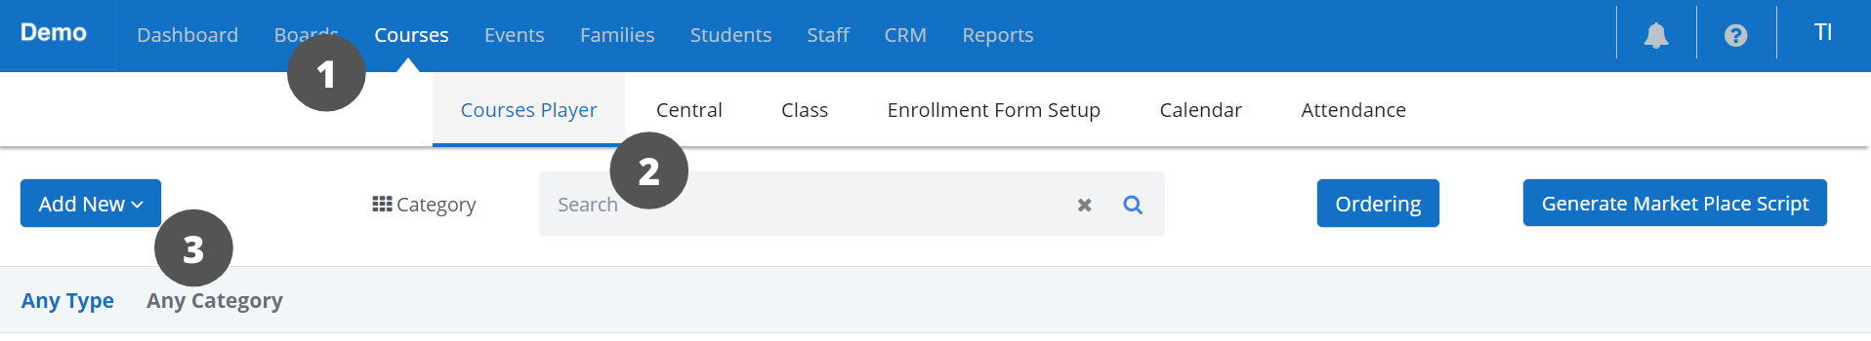

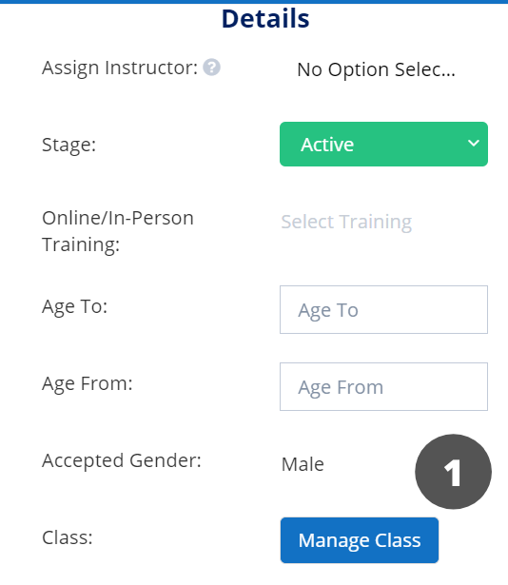

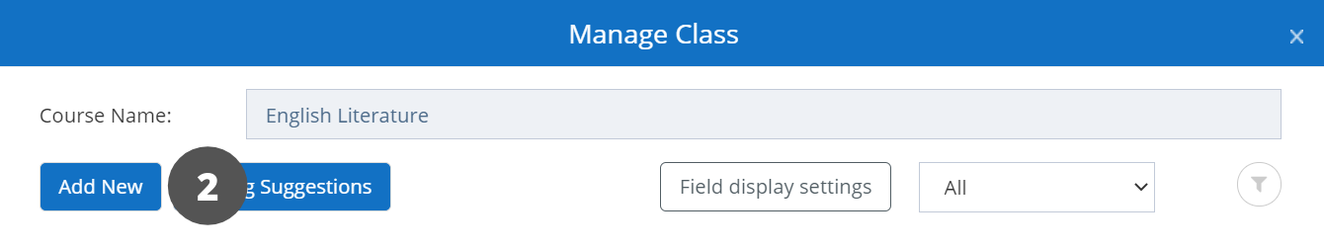

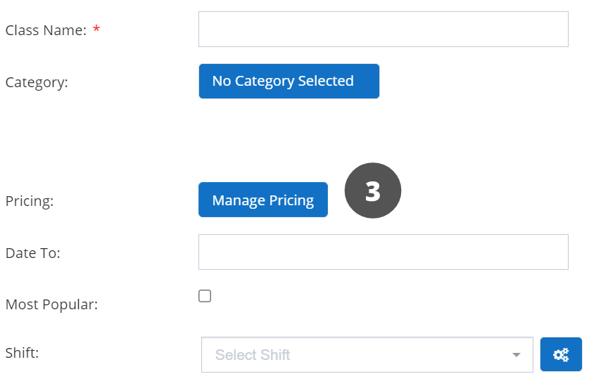

**Create & Manage Events**

Under the *Events* menu select *Events* and click *Create Event* on the opened page. After filling in the required information click *Create*. To Manage Timings and Templates save the event and click on those, fill in information in the popup window. For more in-depth information about creating & managing Events, learn more [here](https://help-lcm.calimatic.com/article?categoryId=11).

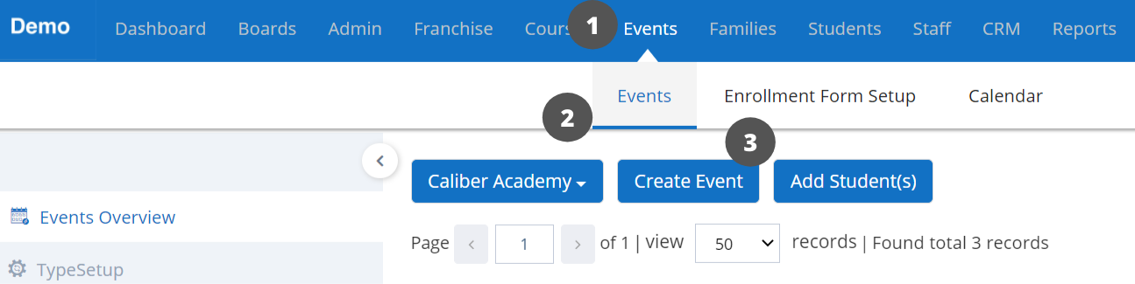

Contact us at hello@calimaticedtech.com for any questions.